Topic: Correlation and Regression
Correlation
Correlation refers to a statistical relationship or association between two or more variables. It measures how changes in one variable are related to changes in another. This concept is widely used in fields like data science, machine learning, computer vision, natural language processing, and database optimization.
Key Concepts:
- Positive correlation: When one variable increases, the other tends to increase.
- Negative correlation: When one variable increases, the other tends to decrease.
- No correlation: No consistent pattern between variables.
Correlation is typically measured using the Pearson correlation coefficient (r), which ranges from -1 to 1:
- +1 → perfect positive correlation
- -1 → perfect negative correlation
- 0 → no correlation

Examples

1. Machine Learning (Feature Selection)
In predictive modeling, highly correlated features can affect model performance. If two features are strongly correlated, one may be redundant.
Example:
- In a dataset predicting house prices:
  - Size in square feet and Number of bedrooms may be positively correlated.
  - Including both might be redundant, so one may be dropped.

2. Computer Vision
In image processing, cross-correlation is used for tasks like template matching.
Example:
- Finding a small template image (like a face) in a larger image.
- The algorithm slides the template over the larger image and computes correlation at each position to find the best match.

3. Natural Language Processing (NLP)
Words in a sentence may show statistical correlation, which can be used for tasks like sentiment analysis or topic modeling.
Example:
- "Great", "fantastic", and "amazing" are likely to appear in positive reviews.
- High correlation among these words can help a sentiment classifier.

4. Recommender Systems
Correlation is used to find users or items with similar preferences.
Example:
- In collaborative filtering:
  - If User A and User B both rated similar movies highly, their preferences are positively correlated.
  - The system might recommend movies that User B liked to User A.

5. Network Security
In intrusion detection systems, correlation can identify related malicious events.
Example:
- Multiple failed login attempts followed by a successful access from the same IP may be correlated and trigger a security alert.

Graphical Presentation of Correlation
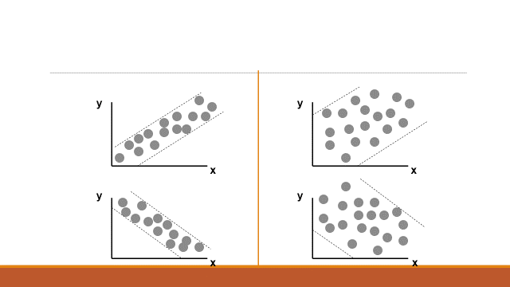
- Which graphs show a positive correlation? How do you know?
- Which graphs show a negative correlation? How do you know?
- Which graph shows the strongest relationship? How can you tell?
- Which graph shows the weakest correlation? What does that imply?
- Does the direction of the trend (positive or negative) affect the strength of correlation?
- If the dots in a scatterplot are widely spread out, what can we say about the value of the correlation coefficient r?

Example
An IT team monitors a web server to check how server load affects response time. They record the following data over different time intervals. Calculate the Pearson correlation coefficient r between Server Load and Response Time.
Interval | Server Load (requests/sec) (X) | Response Time (ms) (Y)
1 | 100 | 120
2 | 200 | 180
3 | 300 | 240
4 | 400 | 300
5 | 500 | 360
Solution

Sr. | X | Y | (X - X̄) | (Y - Ȳ) | (X - X̄)(Y - Ȳ) | (X - X̄)² | (Y - Ȳ)²
 | 100 | 120 | -200 | -120 | 24000 | 40000 | 14400
 | 200 | 180 | -100 | -60 | 6000 | 10000 | 3600
 | 300 | 240 | 0 | 0 | 0 | 0 | 0
 | 400 | 300 | 100 | 60 | 6000 | 10000 | 3600
 | 500 | 360 | 200 | 120 | 24000 | 40000 | 14400
Sum | 1500 | 1200 | 0 | 0 | 60000 | 100000 | 36000

$$r = \frac{60000}{√(10000)(36000)} =\frac{60000}{60000} = 1$$

Regression Analysis
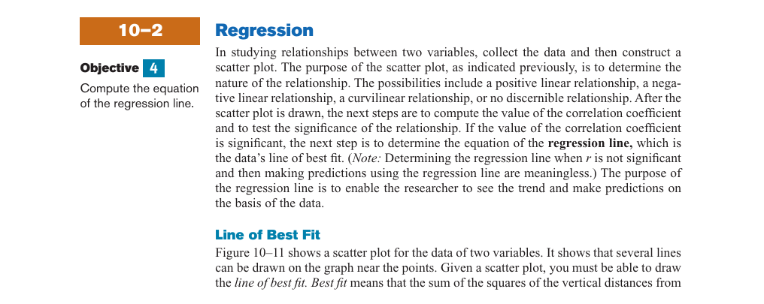

Regression analysis is a statistical method used to model and analyze the relationships between a dependent variable and one or more independent variables. In Computer Science, it is often used to predict outcomes, identify trends, or optimize systems by analyzing patterns in data.
Regression helps you predict one thing (output) based on the values of other things (inputs). For example:
- Predicting software bugs from code complexity.
- Estimating runtime of an algorithm from input size.
- Forecasting server load from number of users.
Key Types of Regression:
- Linear Regression – Models a straight-line relationship.
- Multiple Linear Regression – Uses several input variables.
- Logistic Regression – Used when the outcome is categorical (e.g., spam or not spam).
Examples

1. Software Defect Prediction
- Topic: Using regression analysis to predict the number of software defects based on code complexity metrics (e.g., lines of code, cyclomatic complexity).
- Why it’s good: Real-world relevance in software quality assurance.

📱 2. Mobile App Performance Prediction
- Topic: Regression-based modeling of app energy consumption based on user interaction and device specifications.
- Why it’s good: Combines data science with mobile computing.

🌐 3. Website Load Time Prediction
- Topic: Predicting website load time based on page components like number of scripts, images, and size of resources using multiple linear regression.
- Why it’s good: Practical application in web development and UX optimization.

🧠 4. Machine Learning Model Tuning
- Topic: Using regression to predict model accuracy or training time based on hyperparameters.
- Why it’s good: Useful for understanding ML performance without brute-force tuning

🧮 5. Algorithm Runtime Estimation
- Topic: Applying regression to predict the execution time of sorting/searching algorithms based on input size and type.
- Why it’s good: Bridges theoretical CS and data modeling.

🎮 6. Game Performance Optimization
- Topic: Predicting frame rate (FPS) in 3D games using regression analysis on parameters like resolution, GPU usage, and shader complexity.
- Why it’s good: Great for students interested in graphics and game development.

📊 7. User Behavior Modeling in E-learning Platforms
- Topic: Using regression to predict student engagement time or dropout likelihood based on usage patterns.
- Why it’s good: Combines CS with EdTech and learning analytics.

🛡️ 8. Cybersecurity Risk Prediction
- Topic: Using regression to model and predict risk scores for different network traffic patterns or system vulnerabilities.
- Why it’s good: Timely, relevant, and high-impact.

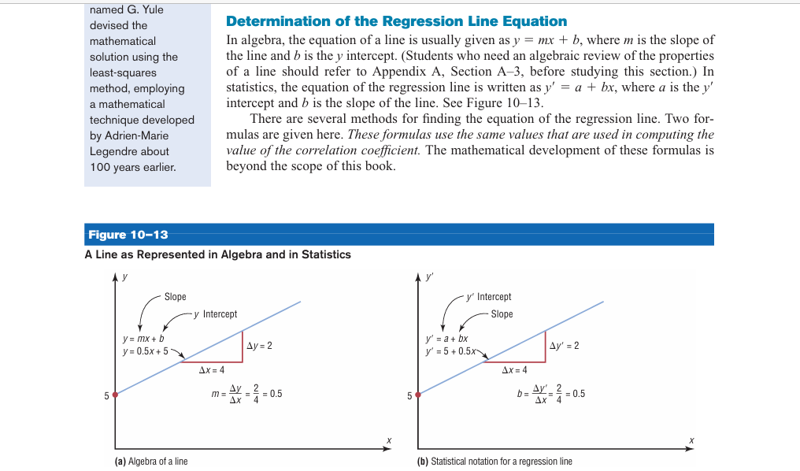
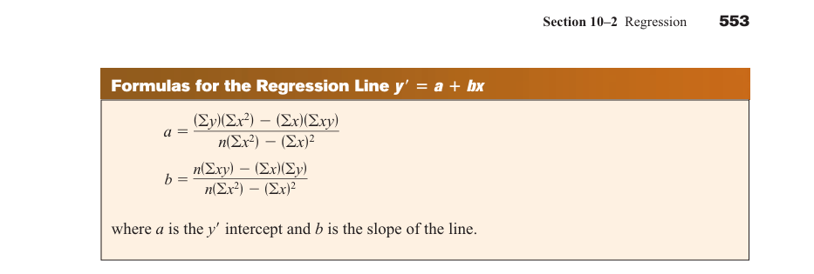

Compute the Regression Line
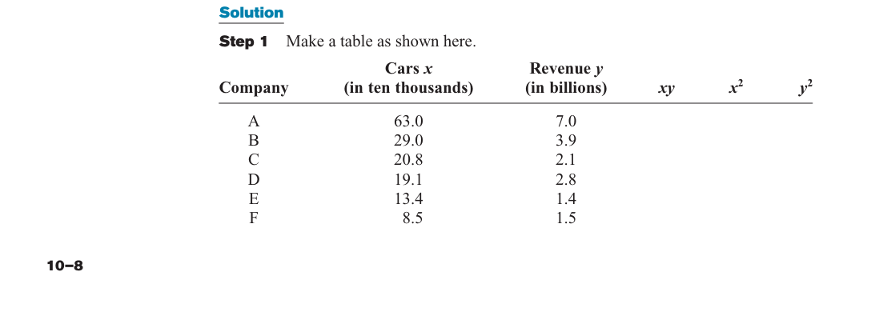
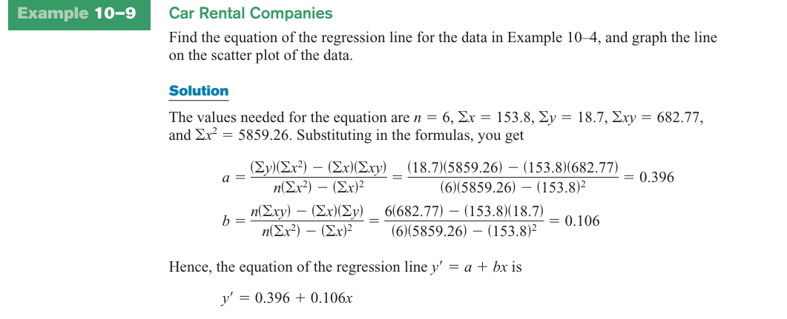

Fit a linear regression model and predict training time for 60 MB dataset.
Training Time(seconds)  Y | Dataset Size (MB)  X | XY
3.1 | 10 | 31 | 100
6.2 | 20 | 124 | 400
9.4 | 30 | 282 | 900
12.5 | 40 | 500 | 1600
15.7 | 50 | 785 | 2500
46.9 | 150 | 1722 | 5500

As Model is, after estimation = .33 and = -0.61
Interpret Your results.
- What is the predicted training time for a 0 MB dataset? Is this reliable?
- If the dataset size increases from 20 MB to 40 MB, how much longer will training take?
- For a dataset size of 60 MB, what is the expected training time?
- Is the relationship between dataset size and training time positive or negative? What does that mean?
- If the model had a much larger intercept, say 10, what might that indicate?
Fit Regression Line
Time (Y) | Complexity (X) | XY
3.5 | 2.5 | 8.75 | 6.25
4.2 | 3.0 | 12.6 | 9
6.1 | 4.0 | 24.4 | 16
7.8 | 5.0 | 39 | 25
9.4 | 6.0 | 56.4 | 36
31 | 20.5 | 141.15 | 92.25

Where,
- Calculate the Value of , and interpret the results.
- Is the relationship between code complexity and maintenance time positive or negative? What does that imply?
- Predict the maintenance time for a complexity score of 4.5.
- If code complexity increases from 3.0 to 5.0, how much additional maintenance time is expected?

